Kutter Aaron

Jacob Ciurca

Will Townsend

Program 1 Report

Our group finished all the assigned tasks. We implemented the code that we needed to for the recieveOnePing function to work properly, and we also added the average RTT, minimum RTT, and maximum RTT. We got some help, mainly from the skeleton code from the book that the program is based off (any other resources are at the bottom). We only met once, which was on Monday, March 15th, from 4-6PM. For the most part, we individually worked on the program and then we came together on Monday to make sure we had relatively the same thing and made sure it worked correctly. We tested our ping function on 5 different addresses, with the first being the local host, and the other four being on four different continents (South America, Africa, Europe, Asia)

Below are the results after running each ping 10 times:

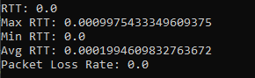

(127.0.0.1) (local host)

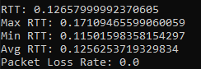

([www.tropenhaus.com.br](http://www.tropenhaus.com.br)) (South America)

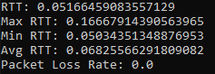

(masrawy.com) (Africa)

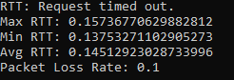

(tu.berlin) (Europe)

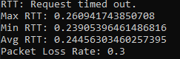

([www.aiit.or.kr](http://www.aiit.or.kr)) (Asia)

References:

<https://www.w3schools.com/python/python_variables_global.asp> (used to find out how global variables work, specifically used for the min, max and average RTT)